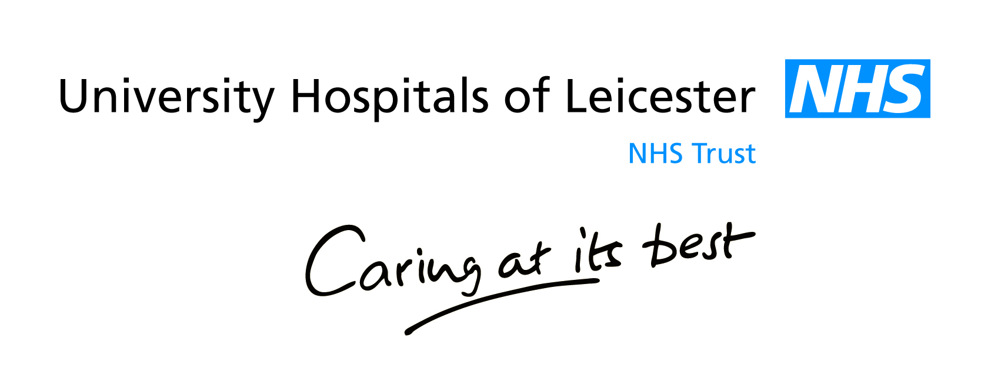

The role of our Caldicott Guardian

Our Caldicott Guardian is our medical director.

In 1997 the Caldicott Committee reviewed the way in which patient information was used within the NHS.

The committee recommended that each trust should appoint a Caldicott Guardian who is responsible for ensuring that patient information is handled confidentially, and shared only for justified purposes using the minimum patient identifiable information necessary.

For further information please contact:

Information.governance@uhl-tr.nhs.uk or

Gareth Lawrence, Information Governance Manager
Tel: (0116) 2586053

